

**PROJECT EMBER**

***The platform for elderly to connect freely***

**Proposed by**

**School of Computer Science and Engineering,**

**Nanyang Technological University**

**TEAM CHAMPIONS**

Arkar Min (U1721052K)

Lee Wan Sin (U1620682G)

Daniel Benjamin Delago (N1804923C)

Jeslynna Teow Zhini (U1622004L)

Ting Jie Yi Rachel (U1621976F)

Georgi Krasimirov Markov (N1800364H)

Sean Tan Jun Yu (U1520094B)

**Table of Contents**

1 Executive Summary3

2 Statement of Problem4

3 Objectives5

4 Technical Approach6

4.1 Plan of Action6

4.2 Customer Needs7

4.3 Target Specifications8

4.4 Technologies Adopted8

4.5 System Architecture9

5 Project Management10

5.1 Planning10

5.2 Concept Development and System-level Design10

5.3 Testing and Refinement10

5.4 Production10

5.5 Division of Responsibilities and Duties10

5.6 Timeline13

6 Deliverables16

7 Budget17

8 References18

Appendix A: Team’s Resumes19

**1. Executive Summary**

The main idea behind our proposal would be to provide a platform for the elderly of our society to interact and mingle with other elderly. This would be to give them a chance to expand their social circle, where interaction with friends would curb their loneliness and give them something to look forward to each day. Our project aims to reduce the number of elderly who are lonely, preventing them from slipping into depression when they no longer have any interest in their surroundings.

With the increase in coaching courses which teach the elderly how to use a smartphone, there has also been an increase in the number of elderlies that use a smartphone. (Yang, 2018) With the motivation to use a smartphone, we would be furthering enhancing their experience by creating an Android application as the platform for them to interact with their peers.

The application consists of a matchmaking algorithm for users to find peers of similar interests, where when both parties give their consent, they would be able to chat with each other.

**2. Statement of Problem**

There has been an increasing number of elderly disregarding death due to a lack of meaningful human interaction, which has aggravated the number of elderly that experience depression, which is an increasing problem in Singapore’s society. (Lin, 2018)

Singapore is currently experiencing an increasingly ageing population, in which the number of citizens aged 65 and above grew by a significant amount of 14.4 percent in 2017. While indeed, if the seniors of our society are able to enjoy a healthy lifestyle and support themselves, there would be a lesser unease in the society. (Toh, 2017)

However, this is regretfully not the case in Singapore, and worldwide. Many people now give excuses that they are too busy and do not have the time to care for the elderly, leaving them to be cared for by nursing homes or to live on their own. (Srivastava, 2017) There has been an increasing number of elderly suffering from depression due to multiple reasons, but with the main reason being loneliness.

Many elderly experience loneliness especially when their partner or friends have passed on. This is especially evident when they have been in each other’s company for a long period of time, in which the feeling of loss is more heavily felt. (Paulo, 2018)

Many elderlies do not believe that their depression is a problem, and only a small handful of them seek for help. However, professionals’ tips regarding how to help them curb depression and loneliness would be for society to help plan and move forward in the elderly’s social aspects of life. (Mind Your Body, 2013)

**3. Objectives**

Our project revolves about the elderly, and there are 3 objectives that we aim to obtain:

1. Helping elderly to make friends
2. Expanding their social circle
3. Curbing loneliness

By using our app ‘Ember’, we introduce the elderly to other elderly who share the same common interests as them, via our matching algorithm who match them based on their common interests.

Once they have found people of similar interests, they would then start chatting with one another, forming a friendship bond between them. As they will be matched to multiple people, they can expand their social circle as they form multiple new relationships. They are even given the option to plan meetups to spend time with one another, enjoy each other’s company and allow them to use their free time to increase their social interaction. This would alleviate their loneliness as they would not be coped up in their housing with little to nothing to do but watching time go by. Critical design issues identified are: use of technology by the elderly and attitude of the elderly to chat and meetup with strangers.

However, in the event that they do not wish to chat with the people they are matched with, we will further expand our matches to find a new set of people of similar interest for them to choose from. ‘Ember’ also focuses on elderly who we define as ages 65 and above, thus people who are below this age are not welcomed to use the application.

**4. Technical Approach**

We intend to deal with the problem by making a mobile application, “Ember”. It will currently be developed for android smartphone usage.

**4.1 Plan of action**

The development of the application, ‘Ember’, permits users to be matched with like-minded individuals and promote interaction amongst the elderly. Firstly, the user can create his/her own account and input some of their own preferences, such as hobbies and interests. This allows the database to match them with others who selected similar or identical preferences.

This application essentially serves as a platform for social interaction. After the elderly are matched with others of similar interests, they will be able to select those of which they want to chat with. If both parties permit, a chatroom will be opened, and they will be able to start communicating with each other. In this way, the elderly would be able to make more friends, reducing the problem of social segregation and isolation.

Furthermore, ‘Ember’ is not restricted to any certain country, race or religion. In this aspect, the elderly may be able to chat with others outside their usual social circle. By communicating with others from other countries, races and religions, they will be able to expand their social circle, understand and learn more about the similarities and differences within the community, and outside of it.

Finally, due to the fact that the elderlies are matched based on preferences and interests, the people they are communicating with would likely share similar interests and hobbies. This allows them a chance to share their likes and dislikes, as well as finding fellowship in others with the same mindset. With such a platform, it is possible for them to seek out companionship, or to engage in activities they would normally shy away from together. With the improvements in social and physical isolation, elderlies would not be faced with the same loneliness as before.

Thus, with these few objectives in mind, it seems vital that our application, ‘Ember’, seeks to fulfil the following identified needs of the elderly.

**4.2 Customer Needs**

As the problem of an ageing society prevails, the elderly are experiencing an increasing segregation from the rest of society. It is so common to find the elderly wandering around alone in parks or at the void decks, with no apparent motive in mind. Thus, our project aims to mitigate this issue, by targeting the needs of our customers, the elderly.

Scouring through the newspapers, it is also apparent that the media is focusing heavily on this matter. One of the many cases is that of Madam Ng Poh Choo, who lives alone in a one-room apartment. (Tai, 2015) From the article, she has outlived her siblings, and also found it hard to keep in contact with her friends. The article brings light to the issue of loneliness and social isolation, which is prevalent in society today.

Thus, one need identified is the need for a platform to meet and make new friends. Unlike the young, the elderly is no longer as healthy or as robust. This makes it inconvenient to travel long distances or partake in strenuous activities in a bid to make new friends. Thus, an application they can access from their homes might be a better choice, providing an easier alternative to interact and communicate with like-minded individuals.

Furthermore, for the past few years, the government has also been putting huge emphasis on the importance of social activities. There is strong avocation at community centres to organize activities targeting the elderly, such as exercising together and going for trips with families and friends. There have also been many researches linking social participation with better health and mentality. (Novek, Menec, Tan, & Bell, 2013) Thus, another need of the elderly identified is a space to discover their own interests and find other individuals pursuing the same goals. One possible deterrence for elderlies in partaking in such social activities is being unaware of such activities and going for them alone. Hence, there is a need for them to interact with others and discover new interests or goals.

However, many of the elderly are not technologically competent. Due to the rapid advancements in technology, the elderly is unable to keep up, and as a result, lack the skills to operate a smart device effectively. Thus, there is also a need to keep the user interface simple so as to ensure that the learning curve is reduced and there is more incentive for the elderly to use the application.

**4.3 Target Specifications**

With our main customers being primarily the elderly, the social platform would be in the form of a mobile application. This is due to the fact that some of the elderly might have some problems with mobility, thus, this would be able to cater to a wide range of elderly. With the mobile application, the elderly will be able to interact and communicate with others around the globe from the comforts of their houses. Furthermore, as there is a chatting function within the application, it would be more convenient to use anything if it were on a mobile instead of the web.

The mobile application, ‘Ember’ would also allow users to select their preferences and interests from a wide range of choices. This simplifies the sign-up process as the elderly would only have to select the options they prefer, instead of typing it out. As the majority of the elderly tend to not be too competent in technology, this would allow them to be able to use the application with greater ease. The buttons and options in the application would also be kept simple to provide an easier interface for the elderly to work on.

Lastly, with the implementation of the matching algorithm as well as the range of interests and preferences, the elderly would be able to interact with others having similar interests. They would be able to learn more from each other and be encouraged to partake in activities conducted externally with encouragement from each other.

**4.4 Technologies Adopted**

We are making use of the following technologies:

* Android SDK
* Java
* MySQL

**4.5 System Architecture**

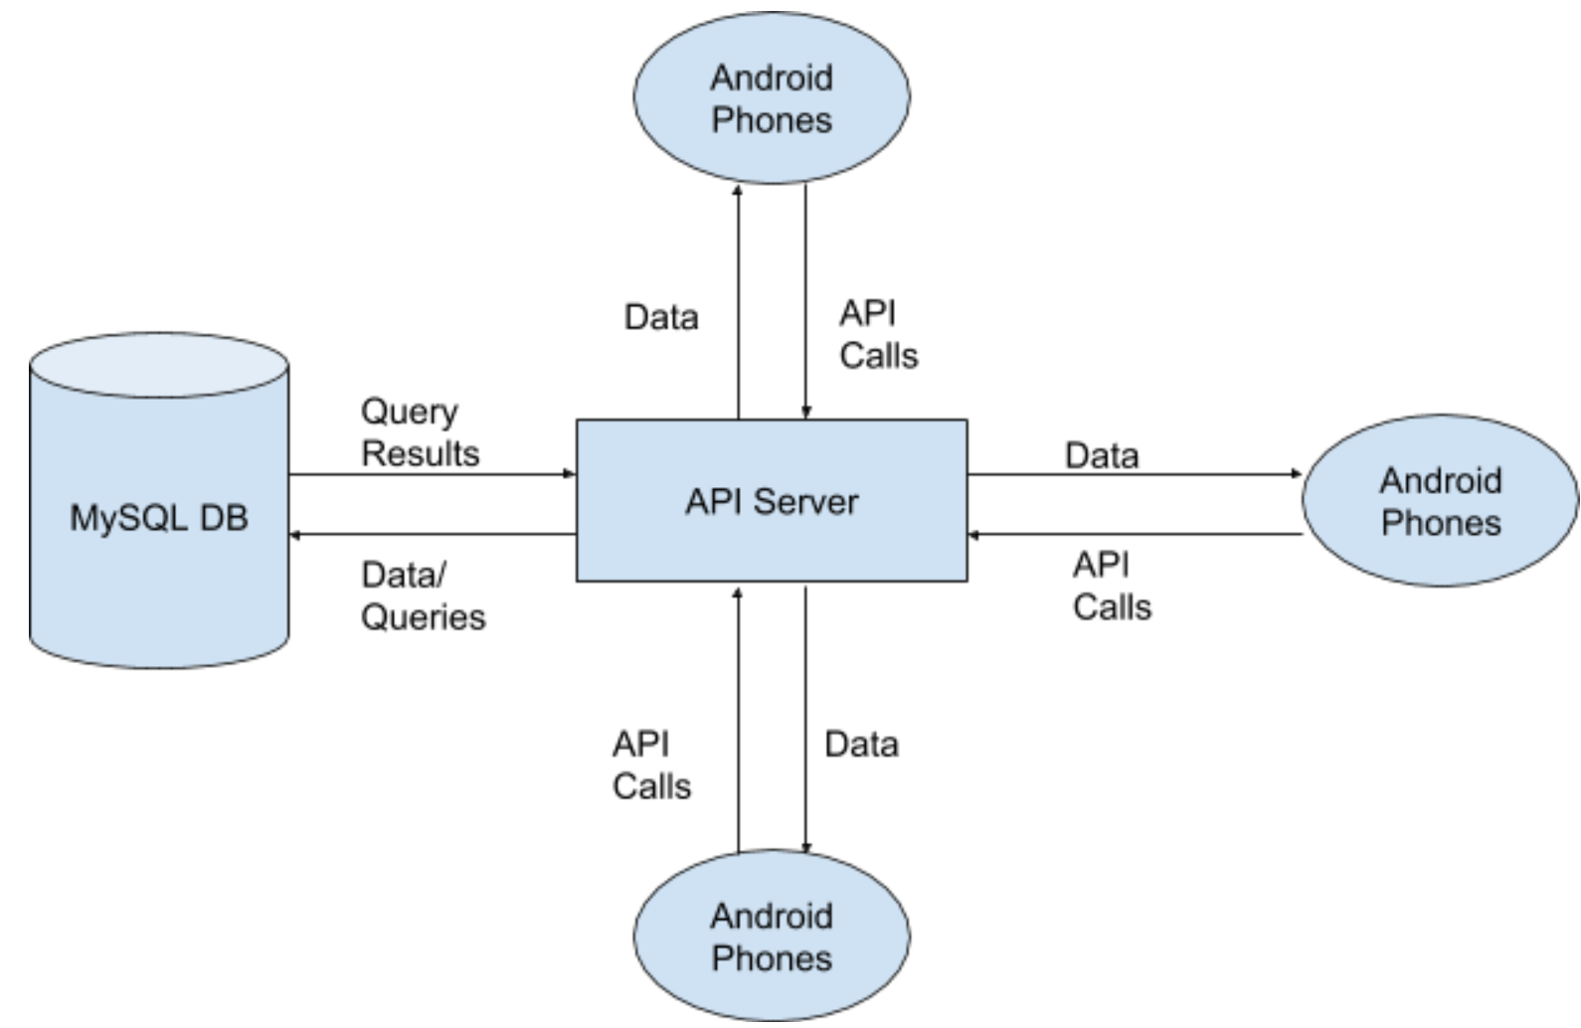

*Figure 1: System Architecture of Ember*

Our implementation will use the client-server model. The Android phones running the Ember app will display the frontend of the application and call the backend API server through RESTful APIs. These APIs are used for functionality including but not limited to: logging in, registration, retrieval of user information and choosing of partners. When chatting with other users, a TCP connection will also be established with the central server through sockets, and messages will be relayed to the other party. The API server deals with the business logic of the application and exposes the APIs needed for accessing data stored in the database. It runs the pairing algorithm which decide which users are potentially good matches. User and chat data will be stored in a MySQL database.

**5. Project Management**

It is a requirement for every member to be involved and know how the system would be to work. Hence, we have split up the different tasks in order for our meetings to be carried out more smoothly and efficiently.

**5.1 Planning**

“Ember: (Android mobile application) will be built by 7 people within a time frame of 10 weeks. All the gathered information will be transformed into use-case model and use case description to clearly define the scope of the project and break the whole project into various tasks. Tasks are assigned to respective members and progress checking will be done on Tuesday for every week.

**5.2 Concept Development & System-level Design**

Design aspects including colour, font and interface design will be chosen to be elderly-friendly. Pairing Algorithm will be developed considering all the aspects to give the best match to elderly. System will also be designed in a way that it is flexible and simple enough to be maintained and extended in the future. Developer will also make sure they strictly follow the design rules.

**5.3 Testing and Refinement**

After product is built by development team, quality engineering and release engineering team will test the product and make bug report. This process will be repeated between engineers and developers until we reach the perfectly worked final product which meet user’s expectation.

**5.4 Production**

This product will be released for free on the Google Play Store. Furthermore, this product will be disturbed to elderly via community centres and social event.

**5.5 Division of Responsibilities and Duties**

|  |  |  |
| --- | --- | --- |
| Name | Role | Responsibilities & Duties |
| Arkar Min | Project Manager | 1. Monitor team’s progresses and deadlines 2. Plan Project Scope 3. Plan System Architecture and Design 4. Develop Use Cases 5. Documentation 6. Involve in overall activities |
| Bernice | Quality Manager | 1. Monitor overall quality of the system 2. Documentation 3. Evaluate the System Architecture and Design 4. Evaluate Use Cases 5. Ensure the final product meets the requirements 6. Develop quality management plan |
| Daniel | Lead Developer | 1. Plan System Architecture and Design 2. Develop Use Cases 3. Oversee the work being done by other developers 4. Choose software development environment and tools 5. Documentation |
| George | Back-End Developer | 1. Plan System Architecture and Design 2. Develop Use Cases 3. Develop the Back-End System 4. Choose software development environment and tools 5. Documentation |

|  |  |  |
| --- | --- | --- |
| Jeslynna | Quality Engineer | 1. Evaluate the System Architecture and Design 2. Documentation 3. Ensure the final product meets the requirements 4. Develop quality management plan 5. Prepare Test Cases |
| Rachel | Release Engineer | 1. Prepare Release Plan 2. Prepare Test Cases 3. Ensure the final product meets the requirements 4. Report Bug Issues to developers 5. Documentation |
| Sean | Front-End Developer | 1. Plan System Architecture and Design 2. Develop Use Cases 3. Develop the Front-End Interface 4. Choose software development environment and tools 5. Documentation |

**5.6 Timeline (with milestones)**

Total Duration - 10 weeks

|  |  |  |  |  |  |  |  |  |  |  |  |  |  |  |  |
| --- | --- | --- | --- | --- | --- | --- | --- | --- | --- | --- | --- | --- | --- | --- | --- |
| Task | Week 1  (20 Aug to 24 Aug) | | | | | Week 2  (27 Aug to 31 Aug) | | | | | Week 3  (3 Sep to 7 Sep) | | | | |
|  | 20 | 21 | 22 | 23 | 24 | 27 | 28 | 29 | 30 | 31 | 3 | 4 | 5 | 6 | 7 |
| Finding Project Ideas |  |  |  |  |  |  |  |  |  |  |  |  |  |  |  |
| Plan Use Case Model |  |  |  |  |  |  |  |  |  |  |  |  |  |  |  |
| Plan Use Case Description |  |  |  |  |  |  |  |  |  |  |  |  |  |  |  |
| Plan System Architecture & Design |  |  |  |  |  |  |  |  |  |  |  |  |  |  |  |
| Plan Front End Design |  |  |  |  |  |  |  |  |  |  |  |  |  |  |  |

|  |  |  |  |  |  |  |  |  |  |  |  |  |  |  |  |
| --- | --- | --- | --- | --- | --- | --- | --- | --- | --- | --- | --- | --- | --- | --- | --- |
| Task | Week 4  (10 Sep to 14 Sep) | | | | | Week 5  (17 Sep to 21 Sep) | | | | | Week 6  (24 Sep to 28 Sep) | | | | |
|  | 10 | 11 | 12 | 13 | 14 | 17 | 18 | 19 | 20 | 21 | 24 | 25 | 26 | 27 | 28 |
| Plan Front End Design |  |  |  |  |  |  |  |  |  |  |  |  |  |  |  |
| Develop Matching Algorithm |  |  |  |  |  |  |  |  |  |  |  |  |  |  |  |
| Develop BackEnd System |  |  |  |  |  |  |  |  |  |  |  |  |  |  |  |
| Develop Database System |  |  |  |  |  |  |  |  |  |  |  |  |  |  |  |
| Add Chat Functionality |  |  |  |  |  |  |  |  |  |  |  |  |  |  |  |
| Testing |  |  |  |  |  |  |  |  |  |  |  |  |  |  |  |

|  |  |  |  |  |  |  |  |  |  |  |  |  |  |  |  |
| --- | --- | --- | --- | --- | --- | --- | --- | --- | --- | --- | --- | --- | --- | --- | --- |
| Task | Week 7  (1 Oct to 5 Oct) | | | | | Week 8  (8 Oct to 12 Oct) | | | | | Week 9  (15 Oct to 19 Oct) | | | | |
|  | 1 | 2 | 3 | 4 | 5 | 8 | 9 | 10 | 11 | 12 | 15 | 16 | 17 | 18 | 19 |
| Testing |  |  |  |  |  |  |  |  |  |  |  |  |  |  |  |
| Bug Fix |  |  |  |  |  |  |  |  |  |  |  |  |  |  |  |
| Quality Management |  |  |  |  |  |  |  |  |  |  |  |  |  |  |  |
| Maintenance Plan |  |  |  |  |  |  |  |  |  |  |  |  |  |  |  |
| Release Plan |  |  |  |  |  |  |  |  |  |  |  |  |  |  |  |
| Prepare Slides for Press Release |  |  |  |  |  |  |  |  |  |  |  |  |  |  |  |

|  |  |  |  |  |  |
| --- | --- | --- | --- | --- | --- |
| Task | Week 10  (22 Oct to 26 Oct) | | | | |
|  | 22 | 23 | 24 | 25 | 26 |
| Rehearsal before Press Release |  |  |  |  |  |
| Final Presentation |  |  |  |  |  |

**6. Deliverables**

Our deliverables will consist of the following:

|  |  |  |
| --- | --- | --- |
| **Deliverables** | **Details** | **Date of Completion** |
| System Requirement Specification | A document containing the details about the goal, objectives and strategies of our entire project. | 18th September 2018 |
| Quality Plan | A document containing details with regards to how we will be ensuring the quality of our prototype, inclusive of our procedures and rules. | 18th September 2018 |
| Physical Prototype | A prototype application which functions similarly, or almost exactly the same as our project’s proposed idea. This is done for client’s review and discussion over more details. | 2nd October 2018 |
| Test Procedures | A document containing the different test cases done in order to check for the functionality of the prototype. | 30th October 2018 |
| Computer Program Code and Documentation | A file of the computer program code and documentation with regards to the prototype. | 30th October 2018 |

**7. Budget**

|  |  |  |  |  |
| --- | --- | --- | --- | --- |
| **Item** | **Supplier** | **Quantity** | **Unit Price** | **Total** |
| Project Manager |  | 1 | $20,000.00 | $20,000.00 |
| Project Team Members |  | 6 | $4,000.00 | $24,000.00 |
| Computers | Asus | 7 | $2,000.00 | $14,000.00 |
| Application License | Android | 1 | $25.00 | $25.00 |
| Development SDK | Android | 1 | $0.00 | $0.00 |
| Database | MySQL | 1 | $5,000.00 | $5,000.00 |
| Office Rental | NTU | 1 | $5,000.00 | $5,000.00 |
| Transportation | Public Transport | 1 | $500.00 | $500.00 |
|  |  |  | **TOTAL** | $68,525.00 |

**8. References**

Lin, M. (January, 2018). Die-logue: Elderly isolation and the need to talk about death.

*Social Space*, p. 4.

Mind Your Body, T. S. (17 November, 2013). Singapore psychiatrist on why elderly are

a misunderstood group. *AsiaOne*.

Novek, S., Menec, V., Tan, T., & Bell, S. (2013). *Social Participation and its benefits.*

University of Manitoba.

Paulo, D. A. (22 April, 2018). 'Like a knife poking my heart': Loss, loneliness and the

killing pain of elderly depression. *Channel NewsAsia*.

Srivastava, R. (14 October, 2017). A world too busy to care for its lonely aged.

*The Straits Time*.

Tai, J. (17 August, 2015). Old and home alone in Singapore. *The Straits Time*.

Toh, E. (28 September, 2017). Singapore ageing at faster pace than a decade again.

*The Straits Time*.

Yang, C. (12 March, 2018). Seniors get coaching on using smartphones. *The Straits Times*.

# **Appendix A: Team’s Resumes**

